Smartwatch tracking app

Author: Mikołaj Moskal

Date: 18.1.2018

Abstract

Goal of project is to create application, that will allow user to track his wearable devices. Application is supposed to generate map based on google maps engine, with drawn route and points, where device, that is being tracked was. Maps will be updated in real time, showing defined by user amount of most recent points with date of recording, and if user would like to keep eye on the latest point, Application will do it for him after selection of this option in option bar.

Requirements

|  |  |  |  |
| --- | --- | --- | --- |
| Must have | Should have | Could Have | Won’t have |
| Working location storing mechanism | Unnoticeable  smartwatch background app | Solid authorization system | Multi OS support |
| Pretty device tracking screen | Low battery consumption | Fit features | Another wearable devices support |
| Login system |  | Generating user statistics feature |  |
|  |  | Anti-theft feature |  |
|  |  | Smartphone friendly web app |  |

Main scenario

1. User runs background application on smartwatch
2. Application sends device location to server
3. User runs tracking application on web browser
4. Login into web application
5. User selects device to track
6. Program displays map with wearable device locations over the time

Use cases

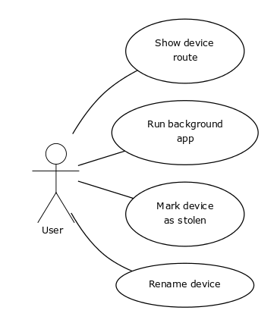

Diagram 1. Use case diagram

Use cases description

|  |  |
| --- | --- |
| Code | UC-1 |
| Name | Show device route |
| Actors | User |
| Initial condition | Internet connection |
| Description | 1.User runs application  2.User logs in  3.User selects device  4.User clicks show route  5.Application generates map with route on it |
| Alternative | 3A User adds new device |

|  |  |
| --- | --- |
| Code | UC-2 |
| Name | Run background app |
| Actors | User |
| Initial condition | Internet connection  Device location turned on |
| Description | 1.User runs background application  2.Device gathers location  3.Device sends location to server |
| Alternatives | 2A Location is turned off  3A Error with internet connectivity |

|  |  |
| --- | --- |
| Code | UC-3 |
| Name | Mark device as stolen |
| Actors | User |
| Initial condition | Internet connection |
| Description | 1.User runs application  2.User selects device  3.User clicks mark device as stolen  4.Application sends information to server |
| Alternatives | 2A User adds new device  4A Error with internet connectivity |

|  |  |
| --- | --- |
| Code | UC-4 |
| Name | Rename device |
| Actors | User |
| Initial condition | Internet connection |
| Description | 1.User runs background application  2.User goes into settings  3.User selects rename device option  4.User selects new name  5.User hit apply button  6.Application sends information to server |
| Alternatives | 4A Name not incorrect  6A Error with internet connectivity |